Assignment 3

Cloud Computing

Name: Shivam Lagdive

Class: Ai-B Batch: B1

Roll No.: 15

**Installing two Virtual Machines on VirtualBox and let them communicate with each other.**

To setup communication between two virtual machines (VMs) in we need to ensure that they are connected to the same network and have appropriate network configurations

Follow the following steps:

**1. Launch VirtualBox:** Start VirtualBox and ensure that both VMs are powered on.

**2. Configure Network Adapter Settings:**

- Select the first VM.

- Open Network tap and check the network adaptor with NAT Network are Available or Not.

- If Not Available Follow Step. click on File menu in VM select the **Preferences** or use Shortcut key. A new Windows are open. Select

**Network -> NAT Networks -> Add NAT Networks**

One network is created. Click On given network and edit NAT network Details**.**

- Repeat these steps for the second VM, ensuring both VMs are connected to the same internal network.

**3. Determine IP Addresses:**

- Use the ifconfig command to determine the IP address of each VM. It is usually under the interface named *eth0* or *enp0s3*.

**4. Ping Each Other:**

- Once both VMs are configured and on the same internal network, we can ping each other using their assigned IP addresses. In the terminal of one VM, use the *ping* command followed by the IP address of the other VM.

ping <other_vm_ip_address>

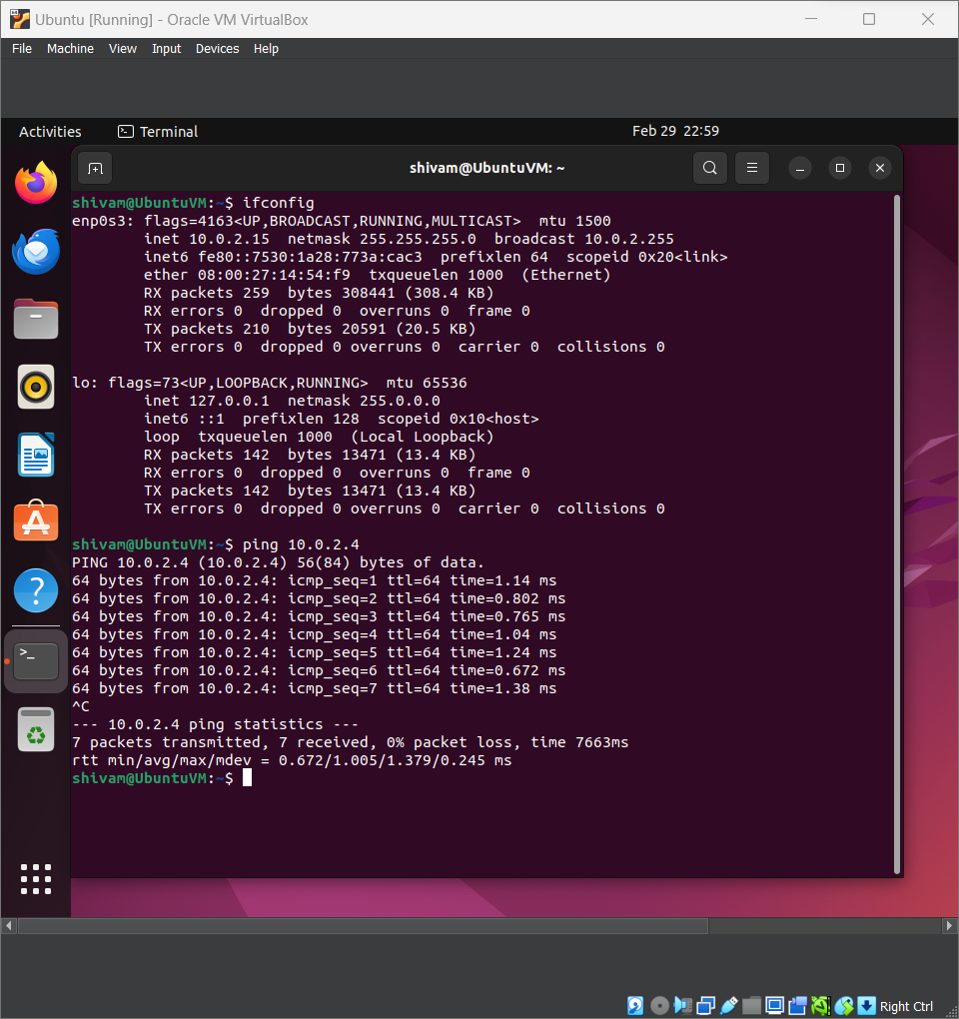

**Ubuntu IP: 10.0.2.15**

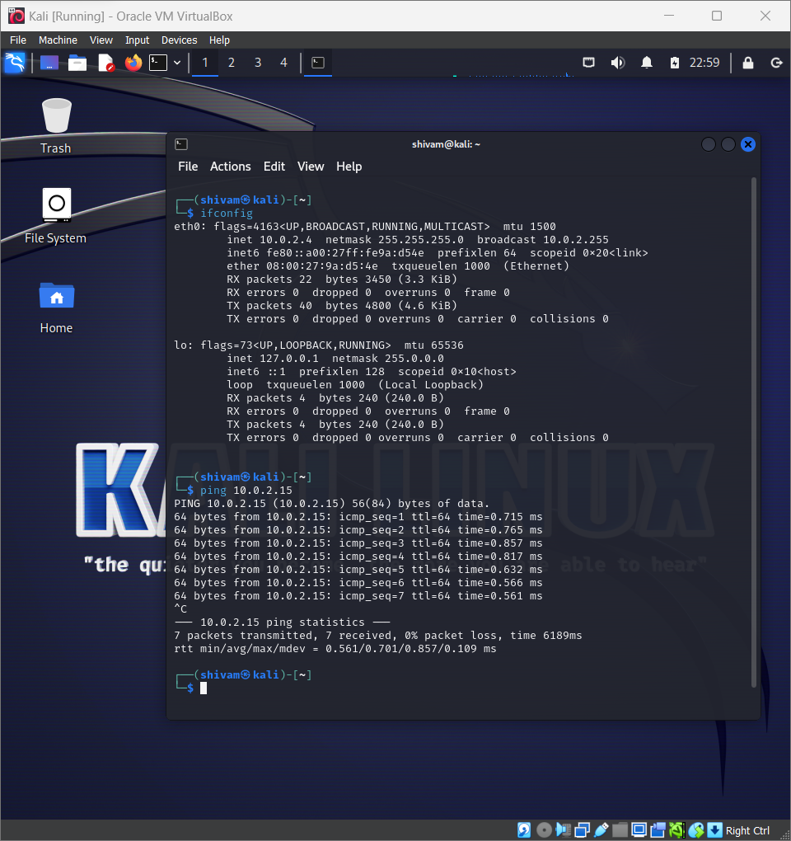

**Kali Linux IP: 10.0.2.4**

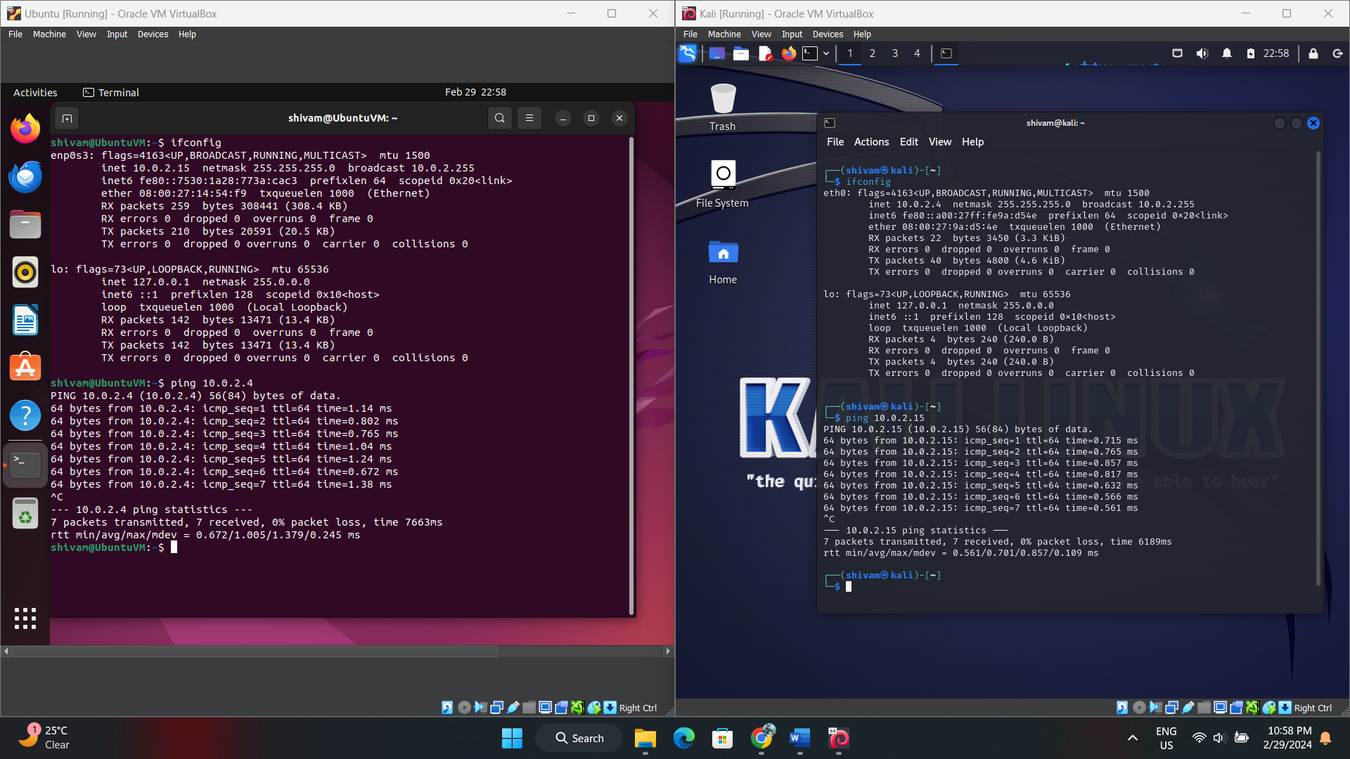

**Conclusion:**

The communication between virtual machines in VirtualBox is facilitated through the use of virtual networking. When we configure VMs to be on the same network, VirtualBox creates a virtual network switch, allowing the VMs to communicate with each other as if they were connected to the same physical network.

By assigning each VM a virtual network adapter and connecting them to the same virtual network, VirtualBox enables data packets to be exchanged between the VMs just like in a physical network environment. This allows for various forms of communication, including ping, file sharing, and application interaction, enabling us to simulate networked environments and test applications in a controlled virtual environment.

Top of Form